Batch: A2 Roll No.: 16010322014
Experiment / assignment / tutorial No.-1
Grade: AA / AB / BB / BC / CC / CD /DD
Signature of the Staff In-charge with date

Title: Task Scheduling Algorithms.
1.FCFS
2.SJF
3.Round robin
4.Non pre-emptive
5.Pre-emptive

Objectives: To perform Theoretical Study and execution of Task Scheduling Algorithms

OUTCOME: Understand architecture, scheduling algorithms and applications of RTOS.

Tool Used: -
Online Simulation Tool

Theory:
Scheduling algorithms schedule processes on the processor in an efficient and effective manner. This scheduling is done by a Process Scheduler. It maximizes CPU utilization by increasing throughput.

Define the below terms
Term | Explanation
Arrival Time | The time at which a process enters the ready queue and is ready to be executed by the CPU
Completion Time | The time at which a process finishes its execution and exits from the system completely
Burst Time | The to complete its execution. This is the number of time units a process requires to be executed by the CPU
Turn Around Time | The total time taken from the arrival of a process until its completion, calculated as Completion Time - Arrival Time.
Waiting Time | The total time a process spends waiting in the ready queue, calculated as Turnaround Time - Burst Time.

Simulation results:

- FCFS(Students are expected to paste screen shots)
Input  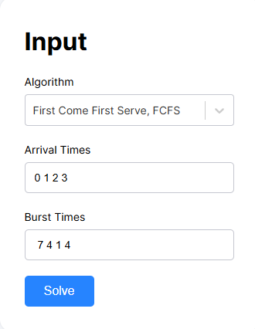 | Output  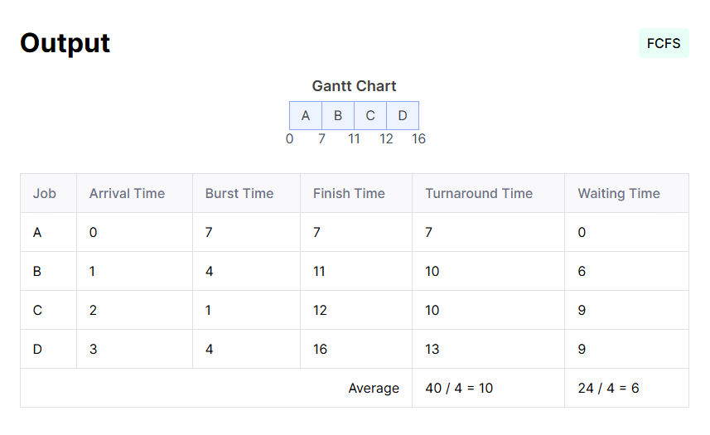

Explanation of the algorithm and output-
FCFS operates like a queue data structure where the process at the head of the ready queue is allocated to the CPU when it becomes free. The algorithm is simple to implement with minimal overhead but suffers from the convoy effect where short processes wait for long processes to complete

- SJF
Input  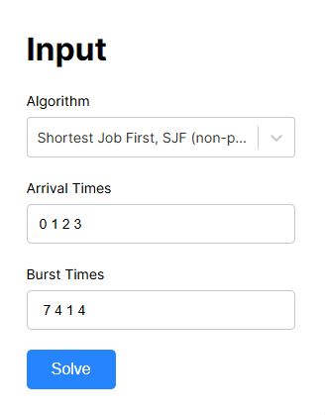 | Output  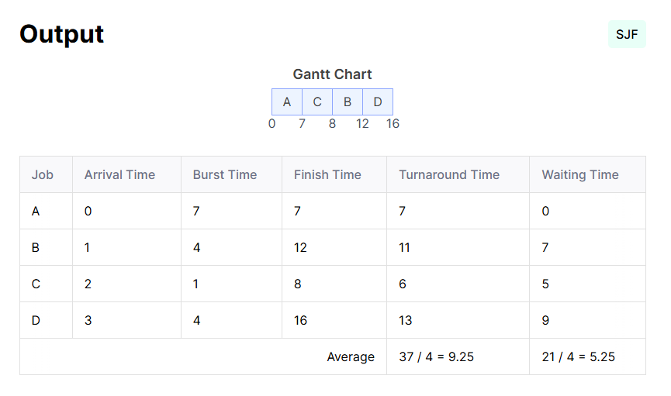

Explanation of the algorithm and output-
SJF selects the process with the smallest burst time from the ready queue. While it provides optimal average waiting time, the algorithm requires advance knowledge of burst times and can lead to starvation of longer processes.

- Round robin
Input  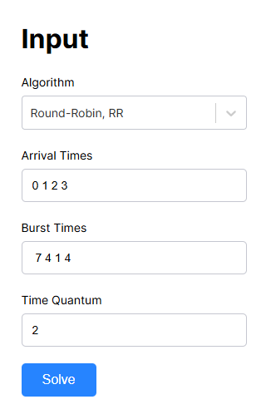 | Output  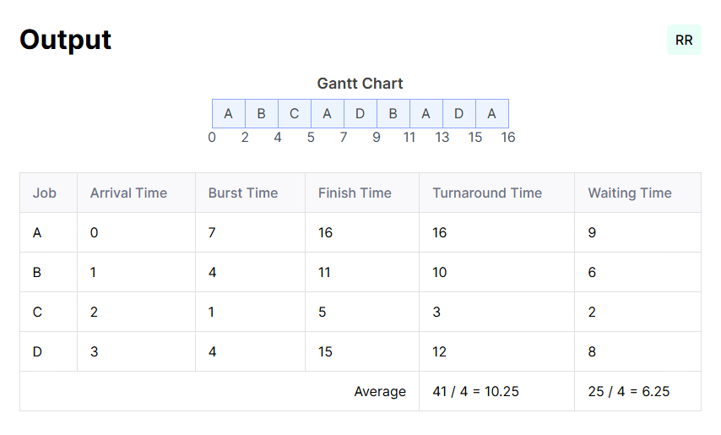

Explanation of the algorithm and output-
Round Robin treats the ready queue as a circular queue, giving each process equal CPU time. The algorithm prevents starvation and provides good response time for interactive systems, though it introduces context switching overhead.

- Non pre-emptive
Input  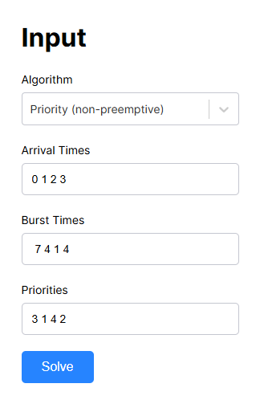 | Output  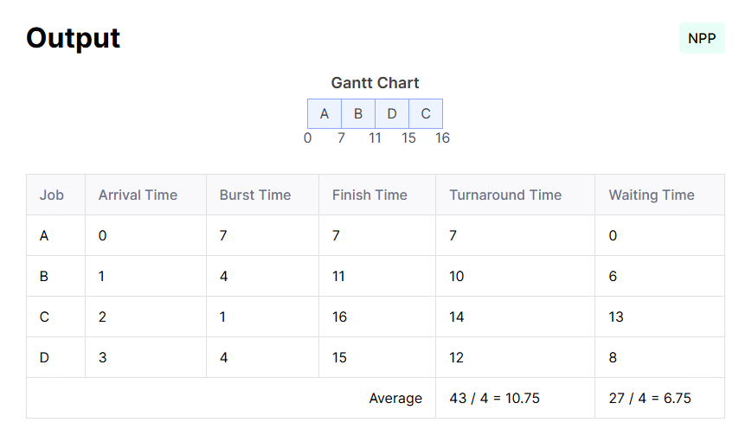

Explanation of the algorithm and output-
This algorithm selects the highest priority process from the ready queue and executes it to completion. While simple to implement, it can lead to starvation of low-priority processes and priority inversion problems.

5. Pre-emptive

Input   | Output  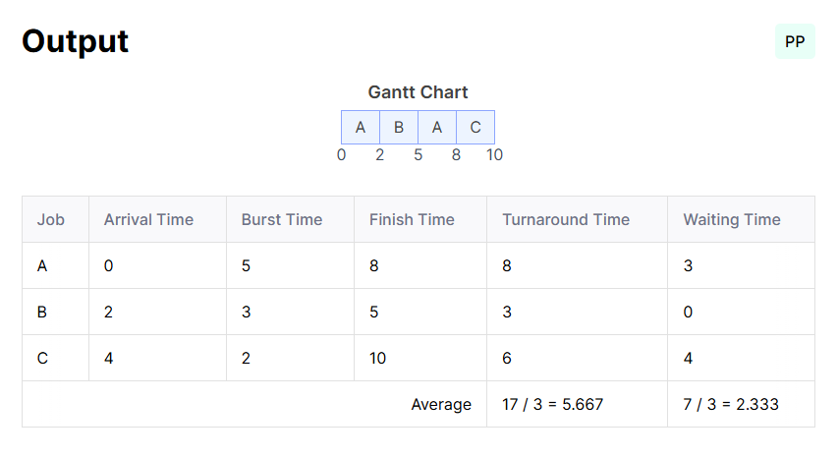

Explanation of the algorithm and output-
This algorithm continuously monitors process priorities and pre-empts the running process if a higher priority process arrives. It provides excellent response time for critical tasks but introduces significant context switching overhead.

Conclusion:
Algorithm | Type | Average Turnaround Time | Average Waiting Time | Key Advantages | Primary Disadvantages
FCFS | Non-pre-emptive | 10.0 | 6.0 | Simple implementation, no starvation | Convoy effect, poor response time
SJF | Non-pre-emptive | 9.25 | 5.25 | Minimum average waiting time | Starvation of long processes
Round Robin | Pre-emptive | 10.25 | 6.25 | Fair allocation, good response time | Context switching overhead
Priority Non-pre-emptive | Non-pre-emptive | 10.75 | 6.75 | Simple priority handling | Priority inversion, starvation
Priority Pre-emptive | Pre-emptive | 5.67 | 2.33 | Best response time for high priority | High context switching overhead

The experimental analysis demonstrates that no single scheduling algorithm is optimal for all scenarios In conclusion, this analysis highlights that no single scheduling algorithm is universally optimal; each has distinct advantages and limitations based on system requirements. First Come First Serve (FCFS), while simple to implement, may result in suboptimal performance due to high waiting times, particularly for processes with longer execution times. Shortest Job First (SJF) minimizes average waiting time but risks process starvation, particularly in systems with varying process lengths. Round Robin (RR), favoured for its fairness and responsiveness in interactive systems, may lead to inefficiency in scenarios with tasks requiring longer execution. Non-pre-emptive scheduling is straightforward but can delay high-priority tasks, while Pre-emptive scheduling enhances responsiveness at the cost of increased overhead from context switching. The selection of a suitable scheduling algorithm depends on specific application needs, such as response time, system complexity, and fairness requirements. In practice, hybrid approaches are often employed to balance trade-offs and optimize overall system performance in real-time and multi-core environments.

Signature of faculty in-charge

